**VISHNU T.S**

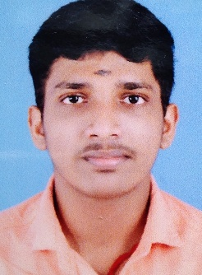

Address : Thekkethottupurathu (H) velliyara,p.o

Plankamon ,ayroor

Pin:689612

Mob : 9207377819

Email I D : vishnuts959@gmail.com

**CAREER OBJECTIVE**

Seeking a career to utilize my knowledge, personal skills to gain comprehensive understanding at a reputed organization, so as to take responsibility and contribute significantly.

**EDUCATION QUALIFICATION**

|  |  |  |  |  |  |
| --- | --- | --- | --- | --- | --- |
| No. | Courses | College/school | Board/University | Percentage | Year of passing |
| 1 | B.Sc. computer science | ST THOMAS COLLEGE, KOZHENCHERRY | Mahatma Gandhi University, Kerala | 6.30 | 2023 |
| 2 | +2 (HSS) | NSS HSS, THADIYOOR | Directorate of Higher Secondary Education, Kerala | 72.25 | 2020 |
| 3 | 10 (SSLC) | S C V H S, KOTTANADU | Kerala State Education Board | 91.11 | 2018 |

ACADEMIC PROJECT

* PORTRAIT PAINTING ONLINE SHOP

The project entitled ‘Portrait painting online shop’ is a website which provides a high quality online service. This site enables us to purchase different artwork from a variety of collections.

Technology used : PHP and MYSQL

**EXTRA CURRICULAR ACTIVITIES**

|  |  |
| --- | --- |
| Activities | Year |
| 2year volunteer experience in  NATIONAL SERVICE SCHEME(NSS) | 2020-2022 |
| Completed all the requirements of  DWITIYA SOPAN BADGE in KERALA STATE BHARAT SCOUTS | 2019 |
| 2 year of STUDENTS POLICE CADET Training  programme(SPC). | 2015-2017 |
| Programming languages known  C CPP java php | Pursuing |

**PERSONAL INFORMATION**

Father’s Name : Somasekharan Nair T D

Date of Birth : 21.06.2002

Caste & Religion : Nair, Hindu

Gender : Male

Marital Status : Unmarried

Languages Known as. : English, Malayalam

Nationality : Indian

Blood group : B+

Languages known. : Malayalam, English

**DECLARATION**

I do hereby declare that the above statement correct and true to the best of my knowledge.

Date :02/012/2022

Place : plankamon **VISHNU T S**